**1. Download and Install PyCharm**

1. Go to the official website: <https://www.jetbrains.com/pycharm/>

**2. Open the Interactive Dashboard Project**

1. Launch PyCharm.
2. Go to File->Open and select the interactive dashboard folder.

**3. Create an Environment for the Project**

1. 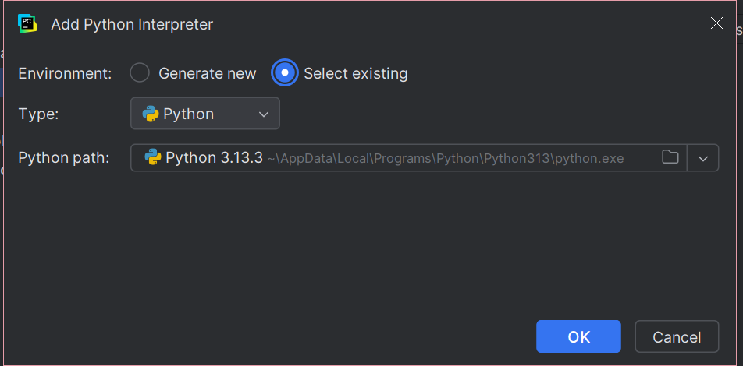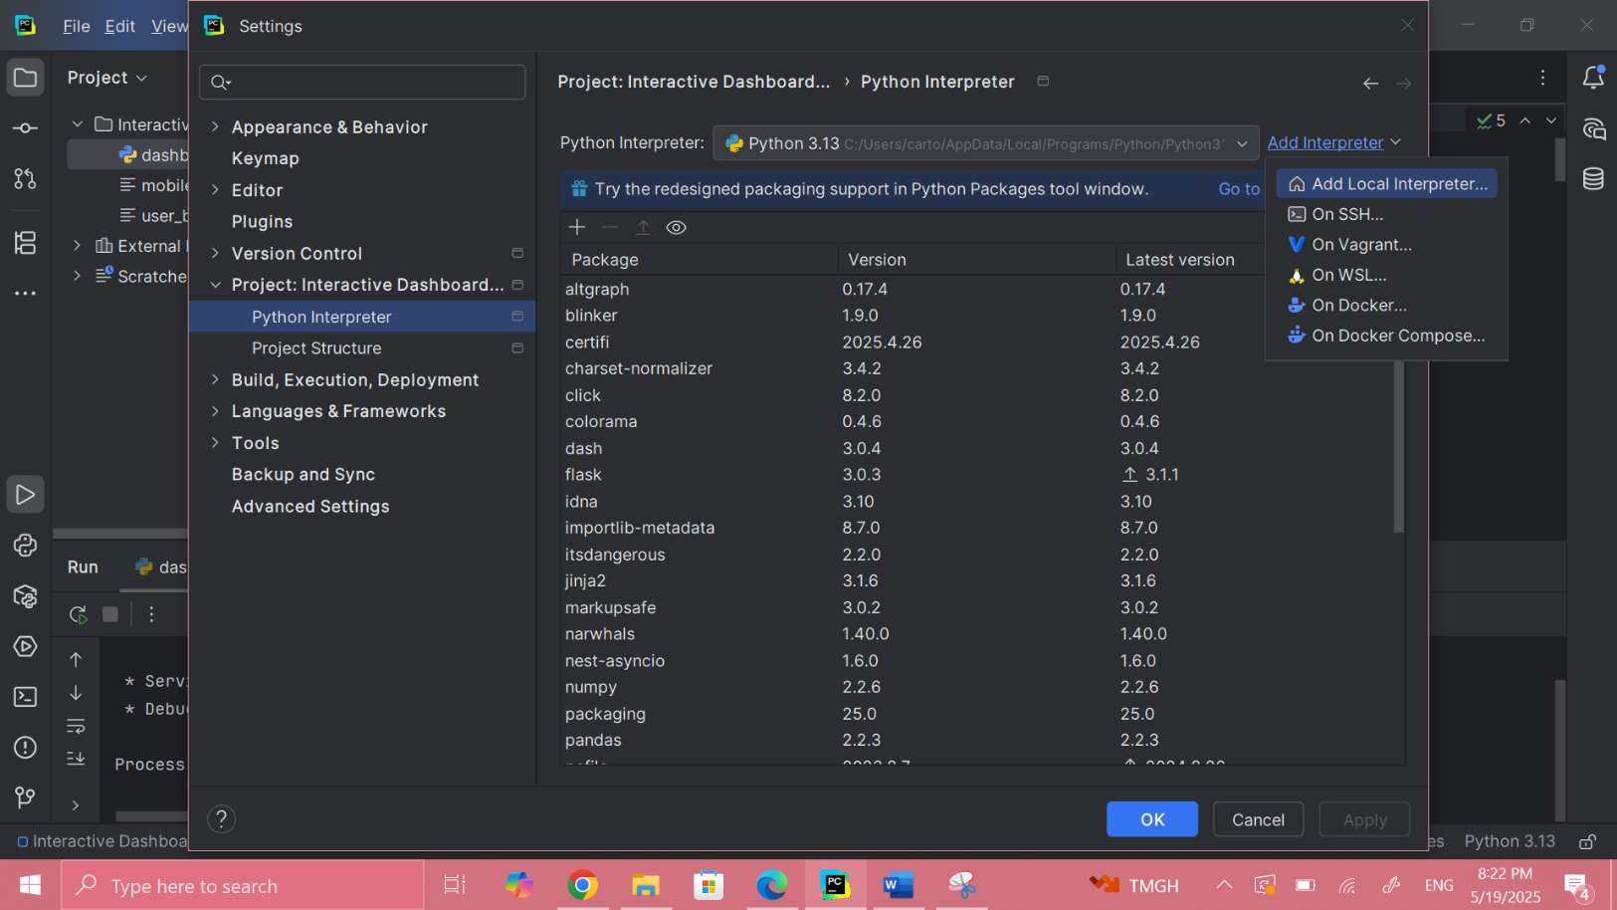Go to File->Settings:

**4. Install Required Libraries**

1.Navigate to the side bar and look for the python packages icon

2.Click on it and download the following libraries: dash, numpy, pandas

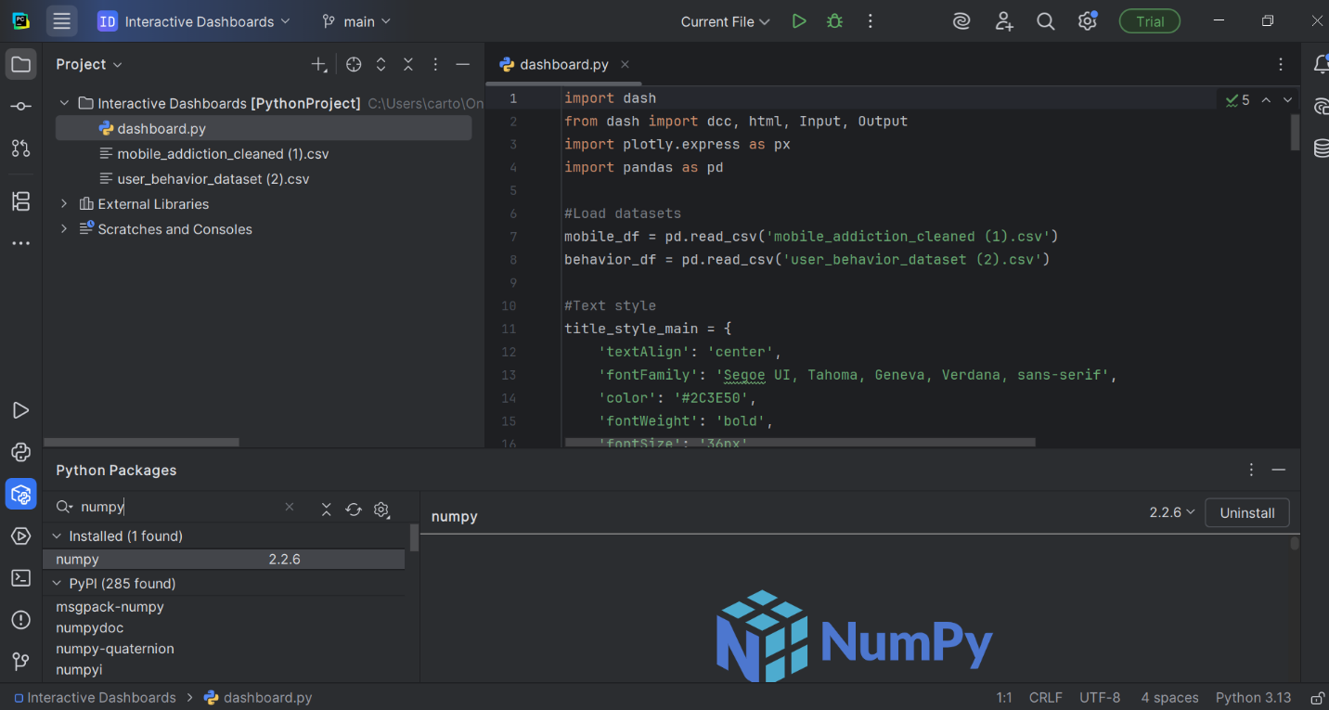

**5. Run Your Dashboard**

1. Click on the Run button
2. Open the local server link (like http://127.0.0.1:8050) shown in the terminal to view the dashboard in your browser.

